Ryan Chen 893219394

Frank Ngo 889272738

CPSC 481

Assignment 3

At this point in time, the project is coming along well. We have completed the two machine learning models used for generating the images and determining whether or not an image is real or fake. We managed to load our dataset into our models, and we trained both our models to a certain extent.

Moving forward, our next task is to implement the application portion of our project and integrate everything together. There should be no issues or difficulties with this portion of the project.

There are some issues that have come up. One issue is with color accuracy when using mathplotlib. When we display our images using that library, the image colors are incorrect. To fix this, we decided to grayscale all of the images. Below are examples of our problem and solution.

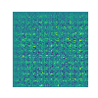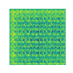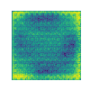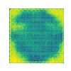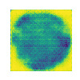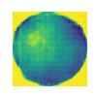

The images above are the results from epoch 1, 25, 50, 75, 100, and 1000 respectively.

(Refer to <https://github.com/CowOfWrath/CPSC-481-Apple-GAN/blob/master/dcgan.gif>)

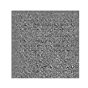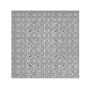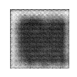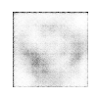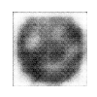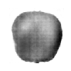

The images above are the results from epoch 1, 25, 50, 75, 100, and 5000 respectively

(Refer to <https://github.com/CowOfWrath/CPSC-481-Apple-GAN/blob/master/dcgan_grayscale.gif>)

The other issue that has come up is the quality of the generated images. There is a tendency for the images to have a gridlike, unnatural texture. While the shape and shading tend to be convincing, the texture makes it quite obvious that the generated images are fake in comparison to the dataset images.

We may have to continue training the model further in order to get better quality images. Another solution would be to alter the model, but the main issue with this approach is that if the model is too big, we would have to lower the batch size in order to get the model to run without having the GPU run out of memory space. This, in turn, causes training to take much longer and it requires a lot of guesswork to get the balance correct.